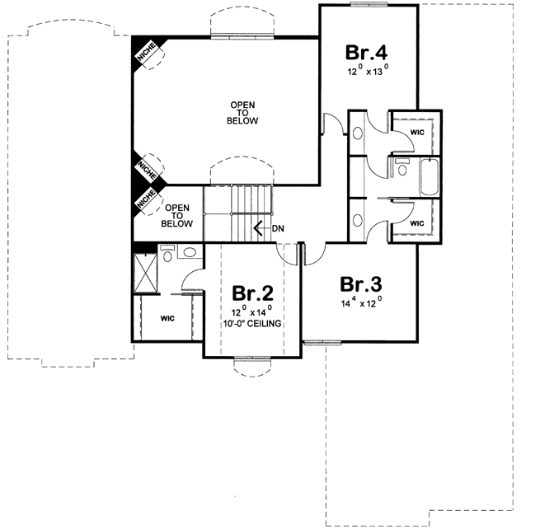
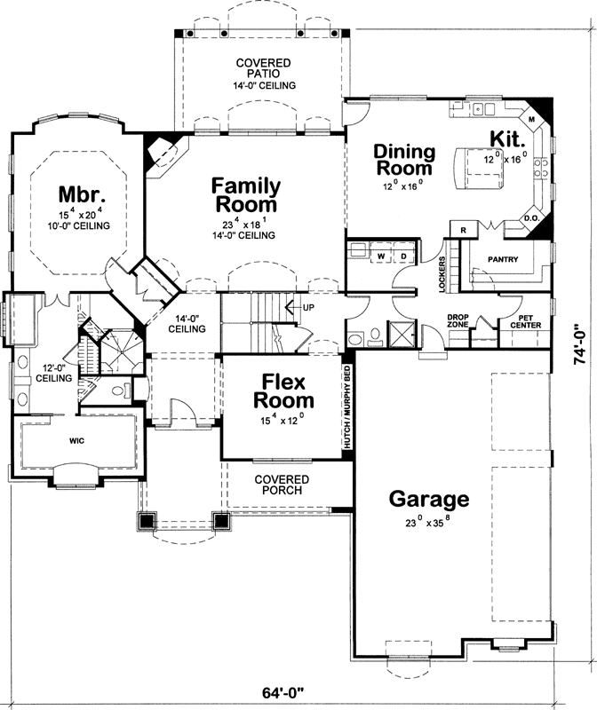
Directions: Using colored pencils, color each zone of the house a different color. Create a key in the box provided.
Then, draw the traffic pattern for your Parent in the morning. Also, in a different color draw YOU traffic pattern in the afternoon.
Key
Service zone
Social zone
Private zone
Parent line:
Your line:

