STORYBOARDING

When you storyboard, you create a planning comic. This helps plan the pictures you want to create with your video step by step. It is alsoa good idea to think about what audio you want in the backround. Will you have a voice over? will you simply play music? Will you use both?

The Google Presentation below can be used as a template with pictures inserted. Or if you would rather use paper, I can print out a paper comic template for you.

Before you move on to filming you must have a storyboard with the following:
1. Use of the presentation template or graphic organizer or hand drawn comic
2. Pictures or sketches of each scene indicating camera angles
3. Notes under the picture of dialogue or audio that will play
You may do this on paper... Or Storyboard Creator!
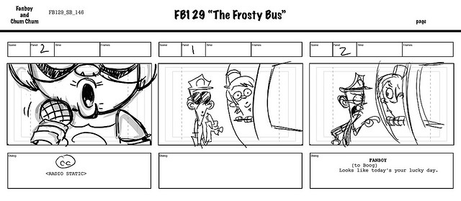
\

Due: by the end of class on Tuesday ( 2-18-14)

